SIT210

EMBEDDED SYSTEMS DEVELOPMENT

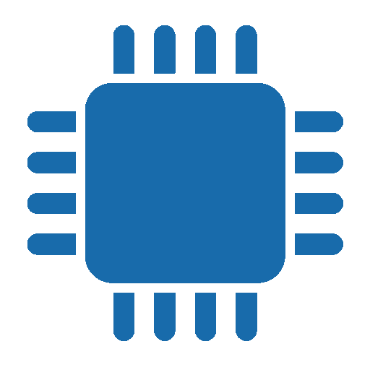

BEN MARRINER

220253518

Learning Summary Report

# Self-Assessment Details

The following checklists provide an overview of my self-assessment for this unit.

|  |  |  |  |  |
| --- | --- | --- | --- | --- |
|  | Pass (D) | Credit (C) | Distinction (B) | High Distinction (A) |
| Self-Assessment |  |  |  | ✓ |

Self-Assessment Statement

|  |  |
| --- | --- |
|  | Included |
| Learning Summary Report | ✓ |
| Pass tasks complete | ✓ |

Minimum Pass Checklist

|  |  |
| --- | --- |
|  | Included |
| All Credit Tasks are Complete on OnTrack | ✓ |

Minimum Credit Checklist (in addition to Pass Checklist)

|  |  |
| --- | --- |
|  | Included |
| Distinction tasks (other than Custom Program) are Complete | ✓ |
| Custom program meets Distinction criteria | ✓ |

Minimum Distinction Checklist (in addition to Credit Checklist)

|  |  |
| --- | --- |
|  | Included |
| Something Awesome included | ✓ |
| Custom project meets HD requirements | ✓ |

Minimum High Distinction Checklist (in addition to Distinction Checklist)

# Declaration

I declare that this portfolio is my individual work. I have not copied from any other student’s work or from any other source except where due acknowledgment is made explicitly in the text, nor has any part of this submission been written for me by another person.

Signature: 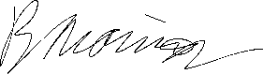

# Portfolio Overview

This portfolio includes work that demonstrates that I have achieved all Unit Learning Outcomes for SIT210 Unit Title to a **High Distinction** level.

This portfolio contains content that is worth a High Distinction grade. I have demonstrated to a high standard the ability to write code that controls devices in embedded systems. Tasks such as sending data to the web, writing an HTML page to control a particle device from the internet and creating a GUI that enables a user to spell their name in morse code with an LED are prime examples of a portfolio worthy of a high distinction.

I have also demonstrated how embedded systems can be used to solve real-world problems. The project I undertook where I prototyped a security system is an example of this.

My portfolio also reflects on the outcomes of the systems I developed throughout this semester. Tasks such as the tutorial video for 2.1P, the project pitch, demonstration and teaching case all serve to complete my understanding of the systems I have built by demoing them, gaining feedback from other students and teaching other students how to assemble their prototypes.

# Reflection

## The most important things I learnt:

Before this unit, I was still unfamiliar with using the hardware we were required to use during the course of this unit, despite coming from SIT123 – Data Capture Technologies. However, I have learned how to best research the components I am using and how to use them. This meant how to configure them to work with Particle devices and Raspberry Pis as well as how to write code that works with them. I also got to know more about the world of systems and ideas for systems that people around the world have come up with daily.

## The things that helped me most were:

I found that all the components we used such as sensors, LEDs and buzzers all have their datasheets that you can refer to. These were very helpful in figuring out how to use them in my systems. The internet also proved to be a useful tool for finding code examples that use these components.

## I found the following topics particularly challenging:

In the beginning, it was quite difficult for me to complete the tasks because I was not familiar with how to use the hardware we were required to buy at the beginning of the semester. However, as I progressed through the tasks, I started learning all the pitfalls that I ran into with them and avoiding them. These could be things such as programs not reading sensor data correctly or sensors not outputting readings correctly at all.

## I found the following topics particularly interesting:

I was required to do a task where I needed to write an HTML page to control a Particle Argon device. This is among one of the most unique tasks in the entire unit. Setting up a Particle device that listens for a specific function call was easy to do since I had done it in a previous task. The interesting part was writing an HTML page to call that function. When this task was complete, I discovered that I could not only control the device from my computer but also my phone. All I had to do was run the webpage on my phone and from there, I had full control of the traffic lights system my particle device was controlling.

## I feel I learnt these topics, concepts, and/or tools really well:

At one point throughout the trimester, I decided to switch from using Particle’s Web IDE to their Visual Studio Code extension Workbench. I thought it was going to be difficult to set up and it was. The reason being that I was not as familiar with Visual Studio Code or the workbench extension. However, after slowly figuring out how it all worked, I felt as though I could make full and proper use of it. I ended up using the Workbench extension for the rest of the unit.

Similarly, I also grasped how to use Visual Studio Code and Python on the Raspberry Pi. For the Raspberry Pi tasks, I wrote all my systems codes using Python in Visual Studio Code.

## I still need to work on the following areas:

There is always room for improvement with my coding. This unit encouraged me to write more code in C++ and Python. Before this unit, I had not touched Python or C++ in a long time. I am glad that this unit has made me more familiar with the two languages but there is of course more room to improve on how well I write using them.

## My progress in this unit was …:

During the course of this unit, I do not believe my workload was spread out enough. I found myself doing more tasks towards the end and not completing any when their start date arrives.

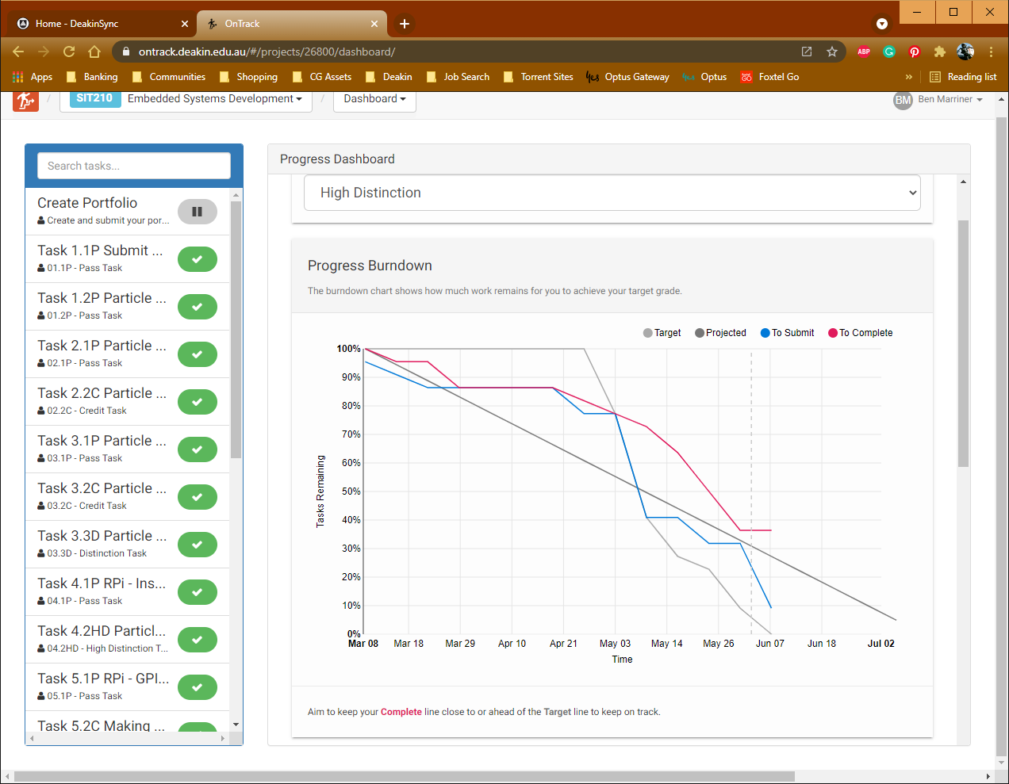

## This unit will help me in the future:

I have always been more of a software person. I do not know as much about hardware as I do with software. However, this unit has equipped me very well with the knowledge of hardware. It has also furthered my understanding of how the systems around me work such as ones used in for example fast-food establishments, retail stores and banks. I feel more confident in my ability to design systems that solve real-world problems thanks to this unit.

## If I did this unit again I would do the following things differently:

This unit has many tasks. I could learn the content of this unit more effectively if I began and completed the tasks within the weeks that they come out.